20.26: (a) Irreversible because heat will not spontaneously flow out of 15 kg of water into a warm room to freeze the water.

(b) 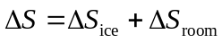

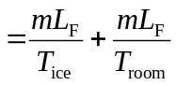

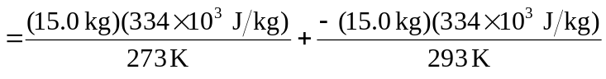

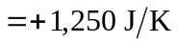

This result is consistent with the answer in (a) because 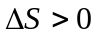 for irreversible processes.

